Ashley Davis
Professor Purvin
Education Field Experience EDUC 230-02
Spring 2012
Classroom Layout

This image is of my ideal High School classroom to teach within. And below are some comments related to this layout.
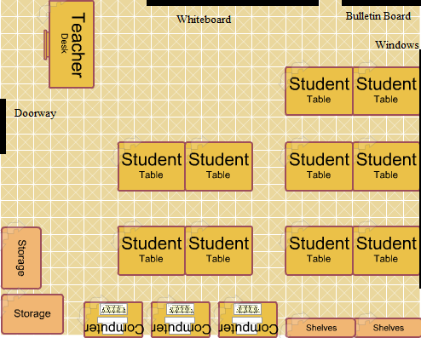

When making this layout I saw each set of desks as having three students placed there thus making a classroom sit of fifteen students. I saw this number as being large enough for group activities and learning but small enough that each student could be given individual attention.
The whiteboard would have a projector aimed at it from the ceiling so that video clips or PowerPoint presentations could be shown when appropriate.
I also left an open are in the front of the room to not only serve as room for me to present lessons but to ensure room is available for student presentations an group activities.
I created this image using the Classroom Architect tool at 4teachers.org and added a few features using black lines in Paint.

